Personal, Social & Emotional Development

Summer Treasure Basket add lots of bright coloured objects.

Create a role-play campsite with tents and

a role-play campfire for children to use.

Make a puppet theatre, like those that

used to be found on beaches, along with

puppets for children to tell

stories with.

Mathematics

Summer pairs matching game.

Sorting Summer & Winter clothing Activity – cut out the objects and sort into groups.

Number matching activity, write the

numerals 1 to 10 on clothes pegs & also around the edge of a yellow-coloured paper plate. Children to fasten the pegs around the edge of the plate by matching the numerals together to create the sun’s rays.

Communication and Language

Old holiday photos – talk about what they see and did in the photos.

Summer Words – use different vocabulary to describe summer/weather and what is in the environment.

Kim's game with summer objects - flowers/grass. Children will enjoy gathering the object to play the game.

Physical Development

Walks in the environment - what sounds can you see and hear.

Make bubble mixture for your child to use, encouraging them to explore blowing bubbles. Challenge them to chase and pop the bubbles too.

Provide brushes with pots of water for children to use to paint pictures onto a dry pavement or wall.

Wrenthorpe Pre-school

Home Learning Activities

Summer

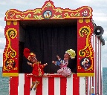

Summer

Understanding the World

Picnic - plan a picnic - make food eg pizza/sandwiches/chocolate crispy buns.

World Map - looking at holiday destinations and talking about where you have been.

Provide magnifying glasses for children to use to explore their surroundings.

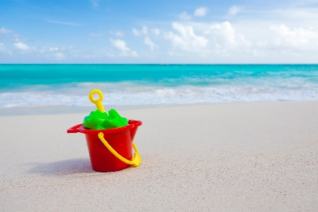

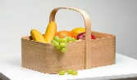

Literacy

Summer Feely bag with different sounds m,a,s,d,t – place objects beginning with the above sounds in a bag & bring each object out for your child to say.

In a shady spot in the outside area, provide the children with clipboards, pencils & paper. Ask them to look and listen to the world around them. Support the children to write a sentence or phrase to describe what they see and hear.

Summer pencil control sheets.

Expressive Arts and Design

Handprint sunflowers – make a sunflower picture using paint and other materials.

Encourage children to explore using

different percussion instruments and noise

makers to represent different summertime.

