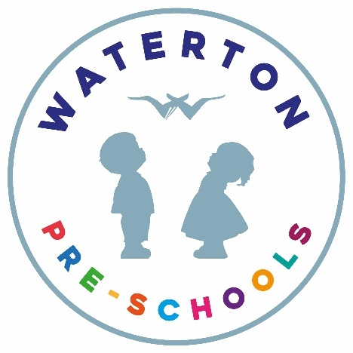
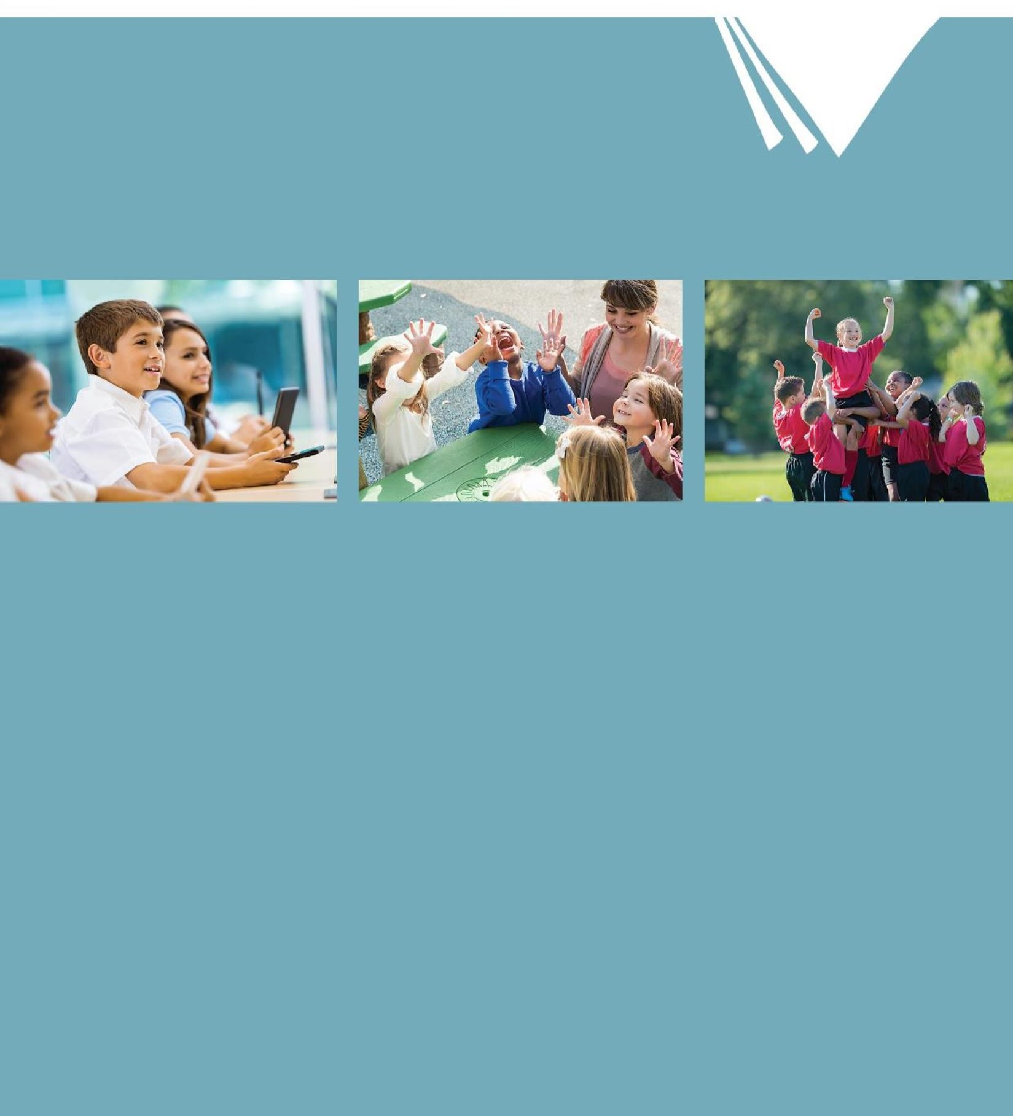
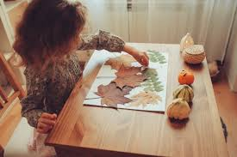
Waterton Pre-Schools

Positive Behaviour Management Policy
WATERTON PRE-SCHOOLS
POSITIVE BEHAVIOUR MANAGEMENT POLICY

The leader of behaviour management at Waterton Pre-Schools is the Executive Headteacher, Becky Cook.

Every adult who works with children in our Pre-Schools will support the development of positive behaviour.

Early Years Foundation Stage: Personal, Social and Emotional Development

Our children will be provided with experiences and support which will help them to develop:
- a positive sense of themselves and of others
- respect for others
- social skills
- and a positive disposition to learn.

We aim through the EYFS for children to:

- understand that their own actions affect other people
- be aware of the boundaries set, and of behavioural expectations in the setting
- begin to be able to negotiate and solve problems without aggression.

“Children’s personal, social and emotional development (PSED) is crucial for children to lead healthy and happy lives, and is fundamental to their cognitive development. Underpinning their personal development are the important attachments that shape their social world. Strong, warm and supportive relationships with adults enable children to learn how to understand their own feelings and those of others. Children should be supported to manage emotions, develop a positive sense of self, set themselves simple goals, have confidence in their own abilities, to persist and wait for what they want and direct attention as necessary. Through adult modelling and guidance, they will learn how to look after their bodies, including healthy eating, and manage personal needs independently. Through supported interaction with other children, they learn how to make good friendships, co-operate and resolve conflicts peaceably. These attributes will provide a secure platform from which children can achieve at school and in later life.” - (Statutory framework for the early years foundation stage Setting the standards for learning, development and care for children from birth to five 2021: p8)

Early Learning Goal

Self-Regulation Children at the expected level of development will:

- Show an understanding of their own feelings and those of others, and begin to regulate their behaviour accordingly;
- Set and work towards simple goals, being able to wait for what they want and control their immediate impulses when appropriate;
- Give focused attention to what the teacher says, responding appropriately even when engaged in activity, and show an ability to follow instructions involving several ideas or actions.

Managing Self Children at the expected level of development will:
- Be confident to try new activities and show independence, resilience and perseverance in the face of challenge;
- Explain the reasons for rules, know right from wrong and try to behave accordingly;
- Manage their own basic hygiene and personal needs, including dressing, going to the toilet and understanding the importance of healthy food choices.

Building Relationships Children at the expected level of development will:
- Work and play cooperatively and take turns with others;
- Form positive attachments to adults and friendships with peers
- Show sensitivity to their own and to others’ needs.

Positive Ethos

Our Pre- Schools are happy, friendly, welcoming places. Our Positive Behaviour Management Policy is very much about developing caring relationships and rewarding good effort, manners and behaviour with clear and developmentally appropriate expectations for the children’s behaviour.

The policy understands the need to respect everyone as individuals and treat them accordingly.
The ethos in our Pre-Schools is very positive and created by caring relationships and in the way all concerned with Pre-School interact with one another.
Every interaction is based on caring professional relationships and respectful acknowledgement of the feelings of children and their families.

We hope to foster a partnership with our parents and children in order to achieve the following aims:

- We aim to teach patience, generosity and respect for people and property by example.
- We aim to develop a child’s self-esteem by promoting opportunities for successful achievements. We reinforce good behaviour by praise.
- We aim to teach children to co-operate, share and take turns.
- We aim to teach children to manage conflicts appropriately, thus in an incident:-
- we try to establish what has happened
- we try to help the children to see the others’ point of view by talking in a calm manner with them
- we try to help them understand when their behaviour is unacceptable

Our Golden Rules: Be SMART:

S - Say ‘Please’ and ‘Thank you’
M - Make friends and be kind
A - Arrive ready to learn and have fun!
R - Respect yourself and others
T - Try your best.

Rewards and Achievements

In our Pre-Schools Every Child Matters. Every effort is made to make the school environment as welcoming both to children and parents as is possible. All staff recognise that children need to be well-motivated in order to function at their best.

In order to promote well-motivated children staff use the following strategies:

a) the use of praise is well established in the form of smiles or words from all staff
b) children share work with staff and receive positive feedback
c) children are rewarded for their efforts and resilience
d) children’s work is valued and displayed for everyone to enjoy
e) photographs are taken of work and put into the children’s 2Simple file or displayed around the setting
f) certificates for completing events are awarded
g) stickers used as appropriate for birthdays or good work
h) each child receives a birthday card and a Christmas card with a Christmas present
i) home/school links via ‘Marvellous Me’ box, Focus Child work, 2Simple and parental consultations
j) advice from support agencies on individual reward systems for children with SEND will be followed and shared with parents/carers
k) sharing interests from home
l) the use of SEAD (Social and Emotional Aspects of Development) and SEADLINGS programmes, to support young children’s PSED (Personal, Social and Emotional Development) in the EYFS (Early Years Foundation Stage).

Actions/Strategies

Staff need to use their discretion according to the needs of individual cases e.g. if a child hurts someone or behaves unsociably they may be asked to play elsewhere.

In extreme cases, the Behaviour Support Service and/or Team Teach Service may become involved in supporting the setting to develop appropriate strategies.

There are times when we need to use behaviour management strategies such as sticker or individual smiley face charts if appropriate for a child. Parents are always kept informed when such strategies are used so that they can give their support.

Role of Trustees

- The Trustees and Committee Members play a key role in influencing the ethos of the Pre-Schools. This influence carries with it a responsibility to support the Executive Headteacher and her staff in maintaining high standards of behaviour within the Pre-Schools.
- The Trustees will review the Pre-Schools behaviour policy every 2 years, or earlier if changes are required or recommended.

Role of the Executive Headteacher

- To encourage good behaviour, care and respect within each Pre-School.
- To discuss and produce the Pre-School Positive Behaviour Management Policy in conjunction withTrustees and staff and to let that policy be known in the Pre-Schools.
- To ensure parents are aware of the Pre-Schools Positive Behaviour Management Policy. Parents are given a welcome pack containing policy, upon their child’s admission into a Pre-School.
- To ensure the policy document is published on the Pre-School’s Website.
- To ensure that the policy is consistently and fairly applied throughout the Pre-Schools.

Role of the Pre-School Manager

- To put the policy on Positive Behaviour management into practice, and apply it fairly and consistently.
- To be available to discuss behaviour issues and concerns amongst children, staff and parents.
- To make children aware of why good behaviour is beneficial to themselves and to others.
- To support staff who are dealing with challenging behaviour.

Bullying

We do not feel that bullying is a common problem in our Pre-Schools.

However, bullying may be distinguished from other unacceptable forms of aggression in that it involves dominance of one child by another, or a group of others, and usually forms a pattern of behaviour rather than an isolated incident. Bullying or other forms of harassment can make a child’s live unhappy and can hinder progress.

If staff feel action is appropriate they must:

- talk to child/children involved
- discuss with whole staff
- agree course of action
- speak with parents
- produce written action/behaviour plan

The LA behaviour management support team may become involved with parental permission through liaison with the Team Around The Early Years. (TAEY)

Racial Harassment

All incidents must be taken seriously and, as with bullying, it must be made clear that such practices are unacceptable and will not be tolerated.

All incidents of racial harassment must be reported to the Executive Headteacher, and logged.

Good Practice
Every Pre-School has a named leader for Positive Behaviour Management; usually the Manager.
They are required to:
  - Keep up to date with legislation, research, and thinking on promoting positive behaviour and on handling children’s behaviour where it may require additional support.
  - Ensure that all staff are ACE aware and understand that all behaviour is a form of communication.
  - Support the staff to understand the individual needs of the children.
  - Check that every member of staff has relevant in-service training on promoting positive behaviour and that up to date training records are kept.
  - Ensure all new staff and volunteers are aware of, have read and understood the Positive Behaviour Policy.
- Work with Area SENCO/Health Visitor, other experts and sources to promote positive behaviour.
Staff will be aware of the individual needs of children and note changes in their usual behaviour. The following factors are important when considering what is acceptable behaviour:
  - a child’s age
  - a child’s personality
  - a child’s maturity
  - a child’s emotional development
  - the home circumstances
  - any special needs the child may require
  - We require all staff, volunteers, and students to provide a positive role model of behaviour by treating children, parents, and one another with friendliness, care, and courtesy.
- We work in partnership with our children’s parents/carers making sure they are informed about their child’s personal, social and emotional development on a regular basis by their keyworker.
- We work with parents to address recurring inconsiderate behaviour by using observation records to help us understand the cause and decide jointly how to respond appropriately.
- We do not use techniques intended to single out or humiliate individual children.
- Physical punishment (smacking, shaking) is never used and children are never threatened with these.
- Every member of staff is aware of the rules of the setting, apply them consistently, and implement agreed strategies for individual children.
- Our well-resourced environments reduce the need for unnecessary conflict over sharing and waiting for turns.
- We avoid creating situations in which children receive adult attention only in return for inconsiderate behaviour.
- We recognise that teasing, rough and tumble play and fantasy play are normal for young children and are acceptable within limits.
- We actively reward good behaviour in a positive, enthusiastic manner so that the children will be aware of their expected behaviour.
- We encourage all children to feel good about themselves and show them what is expected of them.
- Staff will deal quietly and discretely with negative behaviour so that attention is not drawn to it
- Staff will not shout at or raise their voices in a threatening way to children
- If a problem occurs staff will distract the child if possible
- If distraction does not work, staff will remove the child from the situation and discuss their behaviour. Acknowledge their feelings and explain what is not acceptable and how we can put it right.
- We may assign a member of staff to be with a child if necessary.
- We encourage children who have hurt someone to show concern e.g. by helping them up/getting them a tissue/giving them a cuddle.
- Staff offer comfort to intense emotions, helping children to manage their feelings and talk about them to help resolve issues and promote understanding.
- Boundaries agreed with the children are put in place to support play that are understood by them to ensure children are not hurt.

Unacceptable Behaviour that we will challenge and support a child to change:
- Dangerous behaviour (climbing on tables, throwing natural materials, throwing equipment or toys)
- Any behaviour which hurts or threatens another child or adult eg biting, smacking, kicking, punching
- Disruptive behaviour
- Emotionally hurtful behaviour – saying something hurtful to another child/adult
- Bullying – persistent physical or verbal abuse of another child or children
- Swearing or using defamatory language towards or about a person of protected characteristics eg race, sexuality
- Deliberately damaging toys and equipment

Reward for Good Behaviour
Know your child, what celebration do they like? E.g.:
- A clap, cheer, high five, smile, thumbs up . . .
- Words of descriptive praise both private and public (e.g. good tidying up, being resilient, having a go)
- Highlighting the behaviour as a good example to others
- Speaking to parents to give positive feed back

Reviewed: November 2022
Next Review: September 2024

